Урок английского языка в 8 классе по теме «Путешествие по Лондону»
Цели урока:
1. Развитие лексических навыков
2.Тренировка монологической речи по теме « Достопримечательности Лондона»
3.Тренировка навыков поискового чтения

Задачи урока:
Образовательные:
ознакомить учащихся с новым страноведческим материалом по теме «Путешествие по Лондону»;
практиковать поисковое чтение и монологическую речь;
активизировать лексику по теме, расширять словарный запас;
Развивающие:
развивать умение сравнивать и обобщать изучаемый материал;
развивать умение высказать свое мнение на английском языке;
Воспитательные:
воспитывать уважительное отношение к культуре и истории другой страны;
воспитывать умение работать в паре;
расширять кругозор учащихся.

Форма урока: урок – путешествие.
Оборудование: презентация, интерактивное задание о достопримечательностях Лондона, карта достопримечательностей, маркер, компьютер, проектор.
I.Организационный момент
-Good morning, children!( Good morning, teacher!)
- What day is it today? ( Today is the 19-th of December.)
-How are you? ( I am fine/ very well, thank you. And how are you?)

Учитель: Let’s guess, which city we will travel to? (слайд №1)
The aim of our lesson is to learn more about London, its places of interest. We’ll speak about sightseeing, read and listen to a text.

You know many places of interest in London, but about some of them you didn’t hear or know a little. That’s why I suggest you learn more about some of them
But first let’s remember the most famous sights of London (слайд № 2)
(задание на Learningaggs: https://learningapps.org/display?v=pu6xhwdvn22

Match the parts (слайд № 3)
Big  Trafalgar  Bloody  White  Tower  Buckingham  Westminster  The Houses of  The Tower of |  | Palace  Tower  London  Bridge  Ben  Square  Abbey  Tower  Parliament

-Let’s play the game «Agree or disagree» (слайд №4).
Listen to my sentences, please. Repeat my statements if you agree with me and correct them if you disagree with me.
Trafalgar Square is in Moscow.
-London is the capital of the UK.
-London is not an old city
- There are a lot of places of interest in London.
- London is a beautiful city.
London stands on the Amur River
In Backer Street we can visit the museum of the most famous detective.

(Слайд № 5). And now, listen to the poem and tell me what I should give you to begin your adventure:
Мой Лондон умещается в руке – в чердачного кота улыбке странной,
В жемчужинах случайного тумана, в английской розы белом лепестке.
Танцует круговую джигу чай в заварочной стеклянной бальной зале,
Отточенные кисточки мгновений раскрашивают контурные сны –
Я наконец-то научилась Лондон опознавать, как место «там, где ты».
– So, tell me what does it mean? «мой Лондон умещается в руке»? (Ответ: карта).
– You’re right, well done! Take the map, please.(ребята получают карту достопримечательностей Лондона)
I ask you to circle the places of interest which we have just remembered.
(ребята отмечают на карте знакомые им достопримечательности)
Well done!
Look! So many places are new for you. Let’s learn more about some of them.
Let’s take a bus and visit some London museums.(слайд 6)
Read this information and try to guess what museums is this information about (слайды 7-12):

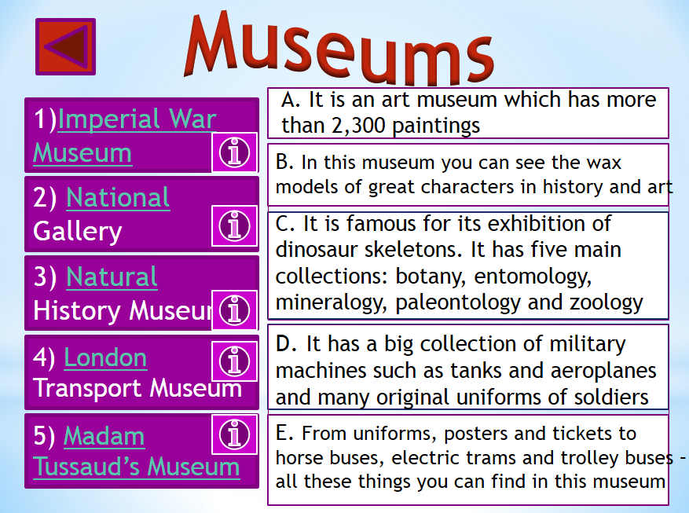
(индивидуальная работа, потом меняются и проверяют друг у друга) 5 points max. Потом ищут эти музеи на карте.!!!!
Физкультминутка (слайд 13)
T: I see that you are tired. Will you stand up? Let’s remember our poem about London and do exercises.
(Учащиеся и учитель вместе рассказывают стихотворение и выполняют упражнения.)

Физминутка
Up, down, up, down,
(Поднимаем руки вверх и вниз)
Which is the way
(Разводим руки в стороны)
To London town?
Where? Where?
(Поворачиваемся в стороны)
Up in the air,
(Смотрим вверх)
Close your eyes –
(Закрываем глаза)
And you are there!
(Открываем глаза)
Our next stop is London parks (Слайды 14-15)
Let’s work in pairs (read the text and make the test) Потом ищут их на карте.!!!!

London parks
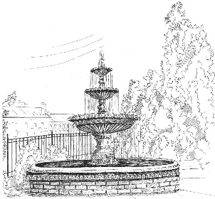
Londoners love their parks and are proud (гордятся) of them. They are full of trees, grass, flowers and small lakes. There are eight Royal Parks in and around London. Four of them are situated in the centre of London: Hyde Park, Green Park, St James's Park and Kensington Gardens.
Hyde Park is the biggest of these four. Londoners ride their bikes and roller-skate on the park roads, play tennis or go horse-riding. There is a place called the Speaker's Corner in the Park.
St James's Park, the oldest of London's parks, is very beautiful with its green trees and colourful flowers and the view of the big palace. This park's lake has been home to many wild birds, including swans, pelicans and geese. In summer there are free concerts in the centre of the park.
In Kensington Gardens, you can see the statue of the famous fairytale hero, Peter Pan. This park is to the west of Hyde Park.
You can also visit Regent's Park where you will find a rose garden, several children's playgrounds, a lake and a theatre, where in summer you can enjoy Shakespeare's plays outdoors. Since 1828 Regent's Park has been home to the London Zoo. The London Zoo is one of the oldest zoos in the world. London's parks and gardens are free to all.
1) There are ______ parks in the center of London.
a) 8 b) 6 c) 4
2) _______ is the biggest park.
a) Hyde Park b) Kensington Gardens c) St James's Park
3) _______ is the oldest park.
a) Kensington Gardens b) St James's Park c) Regent's Park
4) _______ has the special place to public speakers.
a) St James's Park b) Hyde Park c) Kensington Gardens
5) ______ has the statue of a fairytale hero.
a) Regent's Park b) Hyde Park c) Kensington Gardens
6) ______ has been home to the zoo for a long time.
a) Regent's Park b) Kensington Gardens c) St James's Park

Т: Let’s find next place on your map: It is opposite to Big Ben and next to the Tate Gallery (London eye) It will be your homework.

You have a text and tasks. (Слайд 16) (Объяснение домашнего задания)

The London Eye was formally opened by the then Prime Minister, Tony Blair, on 31 December 1999, although it was not opened to the public until 9 March 2000 because of technical problems . It opened in 2000 and was originally going to be a temporary structure to mark the Millennium. The Eye was floated up the Thames in sections and lifted into place by a big crane.
The London Eye is the biggest wheel in the world. It's 135 metres (443 ft) high, and on a clear day you can see all the way to Windsor Castle, which is over 40 km (25 miles) away. It has 32 sections (cabins) and each one holds up to 25 people. Most people buy single tickets, but it is possible to hire out a whole cabin. A ride takes 30 minutes, and as the Eye only travels at just under 1 km per hour, passengers get on and off while it is still moving. However, an average of ten thousand people visit every day, and its massive popularity has ensured that it's stayed put.
The London Eye is on the Southbank of river Thames. It's a 5 minute walk from Waterloo and Westminster Metro Stations.

1 группа – найти ответы на вопросы
2 группа – найти ответы на вопросы)

1 группа
Where is it situated?
Ответы учащихся:
Who formally opened the London Eye?
Ответы учащихся:
Prime Minister Tony Blair.
Is it free or people must pay money for this attraction?

3 группа
Where is the most beautiful view of the city?
Ответы учащихся: The most beautiful view is on the top of the London Eye
How many sections does it have?
Ответы учащихся: 32 cabins are
When was it opened?
Ответы учащихся: It was opened in 1999.

+Творческое задание (презентация про любую незнакомую достопримечательность с карты Лондона)

Подведение итогов урока: (Слайд 17)
What sights of London would you like to visit? Why?
I ‘d like to visit….because…
(ребята отвечают на вопросы)

Cинквейн (слайд 18)
1.Traveling (London)
2.attractive, enjoyable
3.visit, watch, admire
4.it's our life experience
5. Dream
Оценивание работы учащихся на уроке. – Thank you for your work at the lesson today. – You were active. – That’s all for today. Good-bye, my friends

